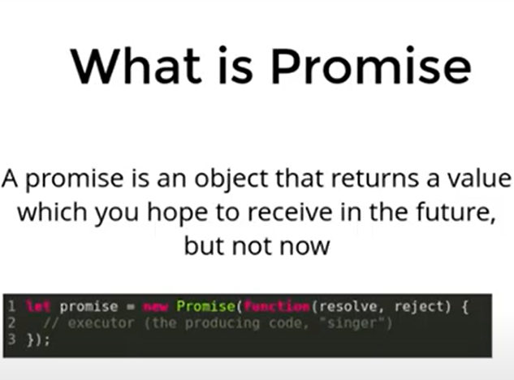

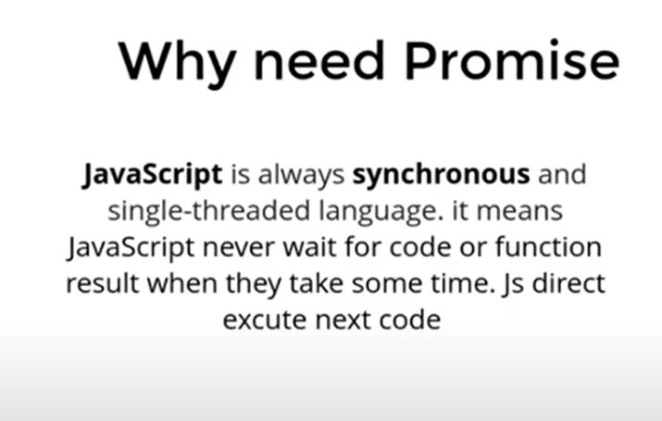

How to handle resolve promise

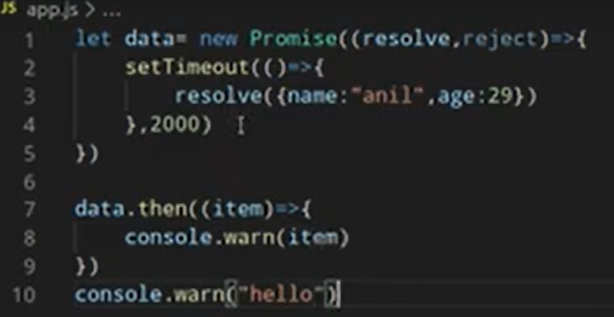

How to handle reject promise

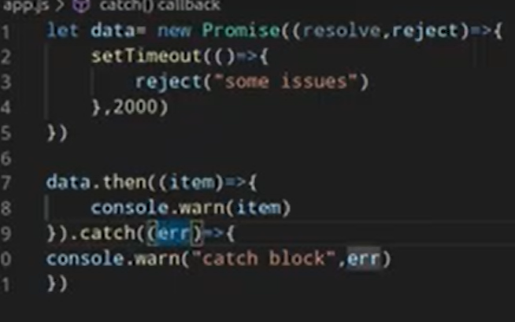

How to get real api with fetch function

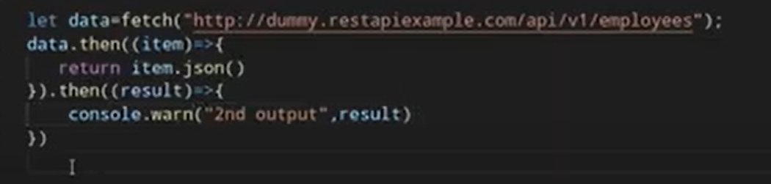

promise chaining

Sometimes, you want to execute two or more related asynchronous operations, where the next operation starts with the result from the previous step. For example:

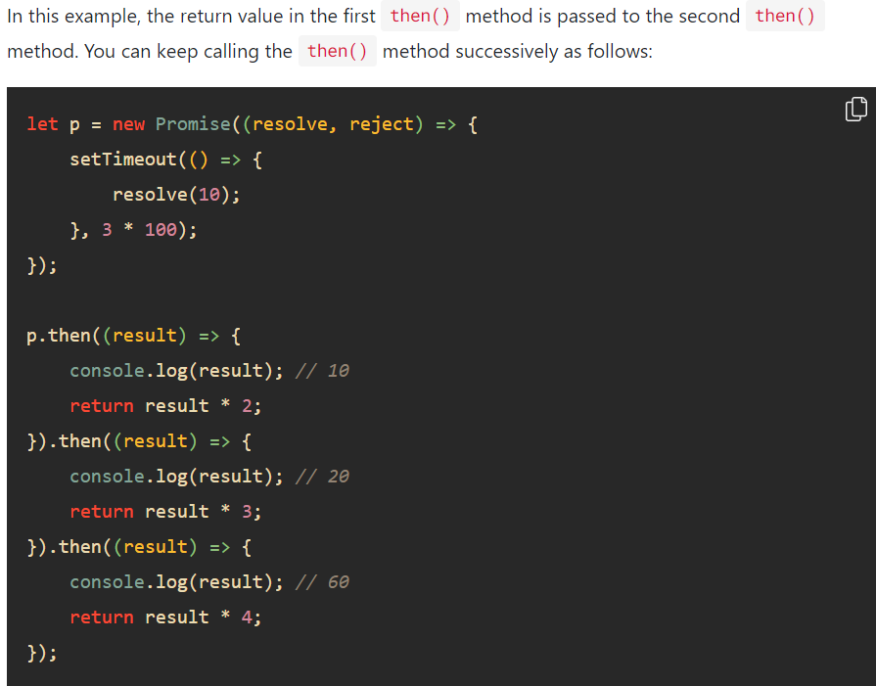

Final keyword

When we don’t need to care promise reject or resolve. That time we use final keyword.

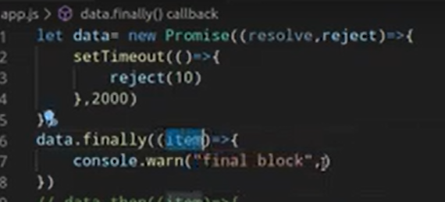

Another example on finally keyword

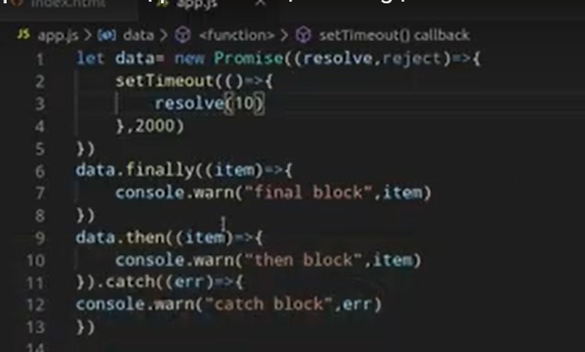

Promise.all

When your 3 promise work together, for example you give 1s for first promise, 2s for second promise, 3s for third promise respectively. Promise.all() work when every promise is resolved.

Promise.allsettled()

It helps to tell how many promise pass or fail

Promise.race()

It works unlike Promise.all().it returns promise when first promise resolve. It says who get first position.